

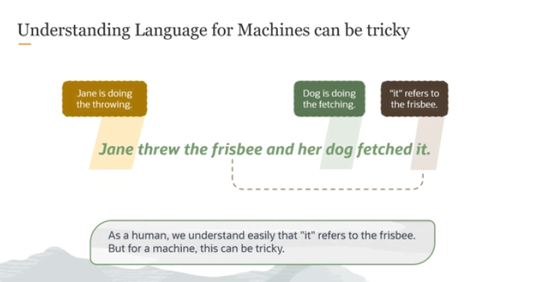

When we talk about "transformer architecture" in AI, we're referring to a powerful model used to understand and process language. Transformers are especially good at handling tasks like translating languages, summarizing text, or even answering questions based on input text. But before we dive into the specifics of how transformers work, let's look at why understanding language is difficult for machines.

Take the sentence: **"Jane threw the Frisbee and her dog fetched it."**

* For us, humans, it's easy to understand. **Jane** throws the Frisbee, **the dog** goes and gets it, and we know that **"it"** refers to the Frisbee.
* However, for a machine (or AI), this is tricky because machines don't "understand" language the way we do. They don’t naturally know what **"it"** refers to. They need to learn how different words in a sentence are related to each other.

Here's why it's hard for machines:

* Machines see the words "Jane," "Frisbee," "dog," "fetched," and "it" as separate pieces of information.
* They don’t automatically know that **"it"** refers to the Frisbee. They need to be trained to understand these relationships between words.

**Transformer models** are designed to help machines understand these relationships better. They can track how words in a sentence relate to each other, even if they are far apart. So, in our sentence, the transformer model will learn that **"it"** most likely refers to **"Frisbee"** and not to **"Jane"** or **"dog"**.

This makes transformer models super useful for complex language tasks because they can understand context better than previous models.

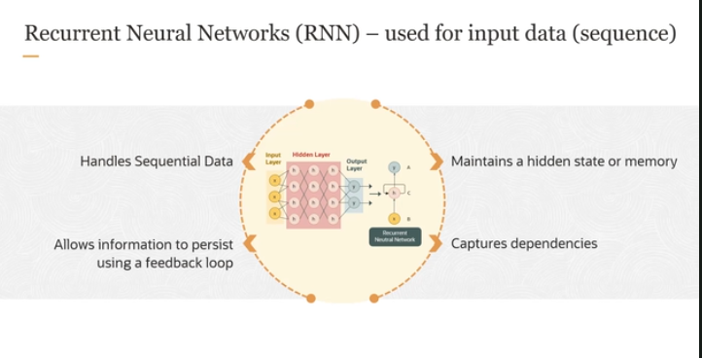

**What is an RNN?**

RNN stands for **Recurrent Neural Network**. It’s a type of neural network used to process sequential data, like sentences, videos, or time-series data.

**How does an RNN work?**

Imagine you’re reading a sentence word by word, one after another. To understand the whole sentence, you need to remember what words came before. An RNN works similarly—it processes data step by step (or word by word), while **keeping track of past information** using something called a **hidden state**.

Here’s how it works in more detail:

* **Feedback Loop:** Unlike regular neural networks that only process data once and move on, RNNs have a **feedback loop**. This loop allows them to **store information from previous steps** and use it when processing the next step.
* **Hidden State (or Memory):** As the RNN processes each word in a sentence, it keeps updating its internal memory, called the **hidden state**. This memory stores important information from previous steps so that the network can understand how the current word fits in with the rest of the sentence.
* **Sequential Processing:** Each word (or element in a sequence) depends on the words that came before it. RNNs are able to **capture patterns and relationships** between words or elements that occur over time, which is crucial for understanding things like sentences, where word order matters a lot.

**Why is this useful?**

RNNs are great for tasks where understanding the order and relationship between data points matters. For example:

* Understanding sentences in natural language processing (NLP)
* Predicting the next word in a sentence
* Processing video frames over time

Now, while this works well for short sequences, it becomes problematic when dealing with long sentences or entire documents.

Let's see the steps for the sentence we saw earlier. So now, as you can see, the same sentence, if RNN is processing the model,

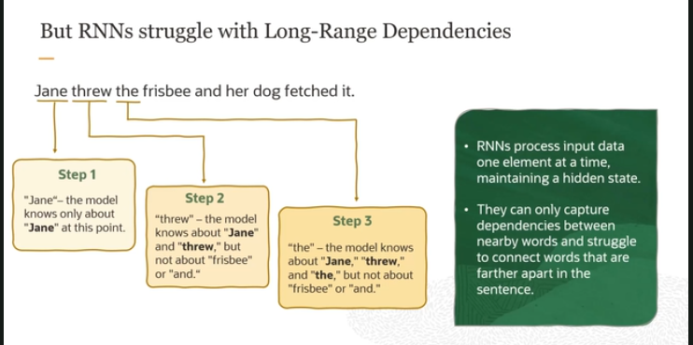

**How RNN Processes Data**

Imagine the sentence: **"Jane threw the Frisbee and her dog fetched it."**

An **RNN (Recurrent Neural Network)** processes this sentence one word at a time, from left to right. At each step, it updates its **hidden state** to store the information it has learned so far. Let’s walk through it:

1. **Step 1: The Model Knows About "Jane"**  
   At this point, the RNN has only processed the first word: **"Jane."** The model’s hidden state contains information about **Jane**, but it hasn’t seen the rest of the sentence, so it doesn't know what’s coming next.
2. **Step 2: The Model Knows About "Jane" and "threw"**  
   Now the RNN has moved to the second word: **"threw."** The hidden state is updated to include information about **Jane** and **threw**. But it still hasn’t seen **"Frisbee"** or the rest of the sentence, so it doesn't yet know what was thrown.
3. **Step 3: The Model Knows About "Jane," "threw," and "and"**  
   The RNN processes the third word, **"and."** Now it has updated its hidden state to include **"Jane," "threw," and "and"**, but still no knowledge of **"Frisbee"** or the rest of the sentence.

This process continues word by word, updating the hidden state each time, slowly building its understanding of the sentence.

**The Challenge with RNNs**

Here’s where things get tricky. RNNs process **sequentially**, meaning they go word by word, **maintaining a hidden state** that holds information from the previous words. However, they face two major problems:

1. **Limited Memory for Long Sentences**  
   RNNs are good at remembering words that are close to each other, but when the sentence gets longer, the model starts to forget important details from earlier in the sentence. For example, by the time the RNN reaches the end of the sentence **"fetched it"**, it might have already lost track of what **"it"** refers to (the Frisbee) because too many words have come between **"Frisbee"** and **"it."**
2. **Vanishing Gradient Problem**  
   This is a common issue with RNNs. As the model moves further in the sequence, the ability to **retain important information** from earlier parts of the sentence weakens. This happens because the gradients (the values the model uses to update its understanding) become smaller and smaller, causing the model to "forget" long-term dependencies.

**Why is this a Problem?**

If RNNs are processing a long or complex sentence, they may struggle to capture important relationships between words that are far apart. In our sentence, for example, the RNN may have a hard time connecting **"Frisbee"** to **"fetched it"**, because the two words are separated by a lot of other words.

**Here comes Transformers that process the whole sequence at once**

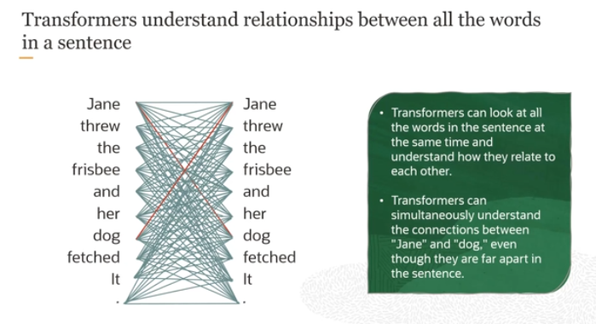

**High-Level Overview of Transformers**

Unlike RNNs, which process words sequentially (one after the other), Transformers can look at an entire sentence all at once. This ability is crucial for understanding complex sentence structures more effectively.

**Understanding Relationships Between All Words**

Imagine you have the sentence: **"Jane threw the Frisbee and her dog fetched it."** A Transformer can analyze and understand all the words in this sentence simultaneously. It doesn’t need to wait to process "Jane" before it understands "dog" or "Frisbee." This is possible due to the Transformer's use of what's called **self-attention mechanisms**.

**Self-Attention Mechanism**

This mechanism allows the Transformer to weigh the importance of each word in a sentence, relative to every other word. This means the Transformer can directly learn the relationship between "Jane" and "dog" and understand that "it" refers to the "Frisbee," no matter their positions in the sentence.

**Visual Representation in Transformers**

In visual terms, if you could see the model’s thinking process, it would look like a network of connections between every word in the sentence, showing how each word influences the interpretation of every other word(ہر لفظ ہر دوسرے لفظ کی تشریح کو کیسے متاثر کرتا ہے۔

). These connections or **interconnects** highlight how words relate to each other throughout the sentence, providing a "bird’s eye view" of the sentence structure.

**Advantage Over Older Models**

Because of this comprehensive view:

* **Contextual Understanding**: Transformers maintain a much better sense of the context within a sentence, making them excellent at handling languages and tasks where understanding the overall sentence meaning is crucial.
* **Efficiency**: They are generally faster to train than RNNs because they process all words in parallel rather than sequentially.
* **Handling Long Sentences**: Unlike RNNs, which struggle with long sentences due to the vanishing gradient problem, Transformers can manage long sentences with ease, retaining the ability to link distant words effectively.

**Conclusion**

Transformers provide a more holistic and interconnected understanding of language, which is why they are at the heart of many state-of-the-art language models, such as those used in generating human-like text or translating languages. They treat sentences as complete entities rather than as a series of individual parts, allowing for a deeper and more accurate interpretation of text.

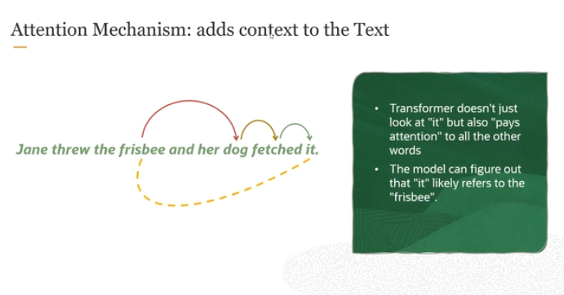

In the transformer architecture, a key feature is something called the **attention mechanism**, more specifically, the **self-attention mechanism**. Let me explain this in a simple yet detailed way:

**What is Self-Attention?**

Imagine you're reading a sentence like: *"Jane threw the Frisbee, and her dog fetched it."*

For a human, it’s easy to understand that "it" refers to the Frisbee. But for a machine, that can be tricky because "it" could refer to anything mentioned earlier, like Jane, the dog, or the Frisbee. The self-attention mechanism helps the model figure out these connections.

**How Self-Attention Works:**

1. **Paying Attention to All Words**: In traditional models like RNNs, the model processes words one by one. But in transformers, the self-attention mechanism allows the model to look at **all words at the same time** and consider how each word relates to the others.

For example, in the sentence "Jane threw the Frisbee, and her dog fetched it," the self-attention mechanism doesn’t just focus on the word "it" in isolation. It also "looks back" at all the other words in the sentence and tries to figure out what "it" refers to.

1. **Weighing Word Importance**: Not all words in a sentence are equally important. In this case, the words "threw," "Frisbee," "dog," and "fetched" are key to understanding what’s happening. The self-attention mechanism assigns weights to these words based on how important they are to understanding the sentence. It learns that "it" is closely related to "Frisbee" because of the actions described earlier.
2. **Building Context**: Because of this mechanism, the transformer doesn’t just consider nearby words, but the entire sentence. This way, it can capture **long-range dependencies**, meaning it can connect words that are far apart in the sentence. For example, the model can easily connect "Jane" and "dog" even though they’re not next to each other in the sentence.

Toh yeh jo **Self-** **Attention mechanism** hai yehi sab say important , bcuz yeh srf koi ek individual word pa focus nhi krta blka puray sentence pay focus krta hai, then usme say sab words ko **weights** assign krta hai and then unme jin words ka weight zeada hota hai wo zeada important hota hai, Or jo context hota hai wo srf nearest words say nhi extract krta blka puray sentence ma say context extract krta hai.

**Why is This Important?**

This self-attention mechanism is crucial because:

* It **improves context** understanding. The model knows that "it" refers to the "Frisbee" because it has been trained to pay attention to the context provided by all words in the sentence.
* It helps the model understand **long sentences** or complex relationships between words, making it more powerful than RNNs, which struggle with long-range dependencies.

In short, the **self-attention mechanism** allows transformers to build a better understanding of relationships between words by considering all of them at once and weighing their importance. This is what gives transformers their powerful ability to process language effectively.

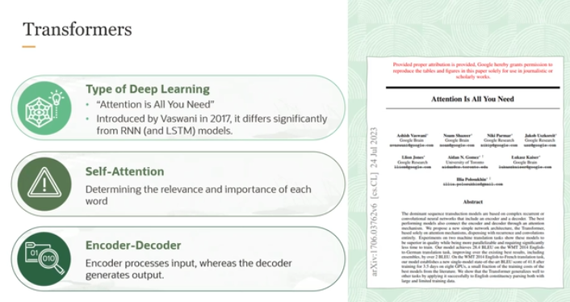

In this explanation, we're breaking down the **transformer architecture**, which is a significant deep learning model introduced by the paper titled "**Attention is All You Need**" (visible in the image). This model represents a major departure from earlier models like **Recurrent Neural Networks (RNNs)** or **LSTMs**, which were traditionally used for processing sequential data like text.

Here are the key components explained:

**1. Transformer as a Deep Learning Model**

* The **Transformer** model is a type of deep learning architecture introduced in 2017 by **Vaswani et al.** in their paper *"Attention is All You Need."* It significantly improved how models understand sequential data (like text) compared to **RNNs** and **LSTMs**.
* Unlike RNNs, which process information sequentially (one step at a time), the transformer model processes the entire sentence or data at once, allowing it to capture long-range dependencies better.

**2. Self-Attention Mechanism**

* At the heart of the transformer is the **self-attention mechanism**. This mechanism helps the model decide the **relevance and importance** of each word in relation to the others in a sentence.
* For example, in the sentence *"Jane threw the frisbee, and her dog fetched it,"* the model uses self-attention to determine that *"it"* refers to *"frisbee"* by considering the entire sentence.
* Self-attention allows the model to understand connections between words, even if they're far apart, making it more effective at handling complex sentences than RNNs, which can struggle with long-range dependencies.

**3. Encoder-Decoder Structure**

* The transformer architecture is divided into two main components: **Encoder** and **Decoder**.
  + **Encoder**: This part processes the input (like a sentence), converting it into a series of **numerical representations** (or **vectors**). These vectors carry **contextual information** about the sentence, like the meaning and relationships between the words.
  + **Decoder**: This component takes the encoded vectors from the encoder and generates the **output text** (like a translation or a prediction). It uses the context provided by the encoder to produce meaningful output.

**4. Layers and Connections**

* Both the encoder and decoder consist of **multiple layers**, and each layer is connected by the **self-attention mechanism**. This allows the model to build deeper understanding and relationships between the data at different layers.

In short, the **transformer** is a more powerful and efficient model than earlier architectures like RNNs, thanks to its use of **self-attention** and its ability to process information in parallel, rather than step-by-step.

For more on transformer: <https://github.com/panaversity/learn-applied-generative-ai-fundamentals/tree/main/19_genai_foundations/02_generative_ai/03_transformers>

Nvidea: <https://blogs.nvidia.com/blog/what-is-a-transformer-model/>